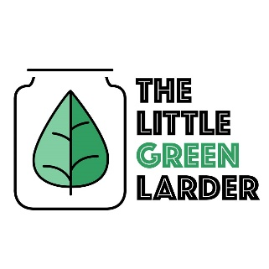

The Little Green Larder The Little Green Larder

Sweet Potato and Chick Pea Curry Bag Sweet Potato and Chick Pea Curry Bag

2 – 3 cloves of garlic  
2 tbsp curry paste  
1 tsp curry powder  
1 onion  
1 Sweet potato  
1 Carrot  
200g chick peas  
Can coconut milk  
150g rice

- Soak chickpeas for 4 – 8hours (we just leave them overnight), rinse then place in a pot of water. Bring to boil then simmer for 1 hour. Drain and set aside

- Peel and chop your garlic and veg

- Fry onions and garlic in oil for 1min then add curry paste and fry a further 2 mins

- Add can of coconut milk, stir then add sweet potato and chick peas. cook for 10 mins

- Add carrots and cook for 10 – 15 mins

- Serve with Rice

Serves 2 Serves 2

2 – 3 cloves of garlic  
2 tbsp curry paste  
1 tsp curry powder  
1 onion  
1 Sweet potato  
1 Carrot  
200g chick peas  
Can coconut milk  
150g rice

- Soak chickpeas for 4 – 8hours (we just leave them overnight), rinse then place in a pot of water. Bring to boil then simmer for 1 hour. Drain and set aside

- Peel and chop your garlic and veg

- Fry onions and garlic in oil for 1min then add curry paste and fry a further 2 mins

- Add can of coconut milk, stir then add sweet potato and chick peas. cook for 10 mins

- Add carrots and cook for 10 – 15 mins

- Serve with Rice